EXPERIMENT - 4
AIM –
To design and develop a Dynamic To-Do List web application using HTML, CSS, and JavaScript that allows users to add, edit, delete, and mark tasks as completed.

TASK –
Project Setup & Introduction – Create project folder and link HTML, CSS, JS files.
To-Do List Interface – Create input field, add button and task list display.
Styling with CSS – Apply clean layout, spacing and readable design.
JavaScript Functionality – Add tasks dynamically and prevent empty inputs.
Edit & Delete Features – Modify and remove tasks dynamically.
Task Completion Status – Add checkbox and show completed vs pending tasks.
TECH STACK USED –

HTML-
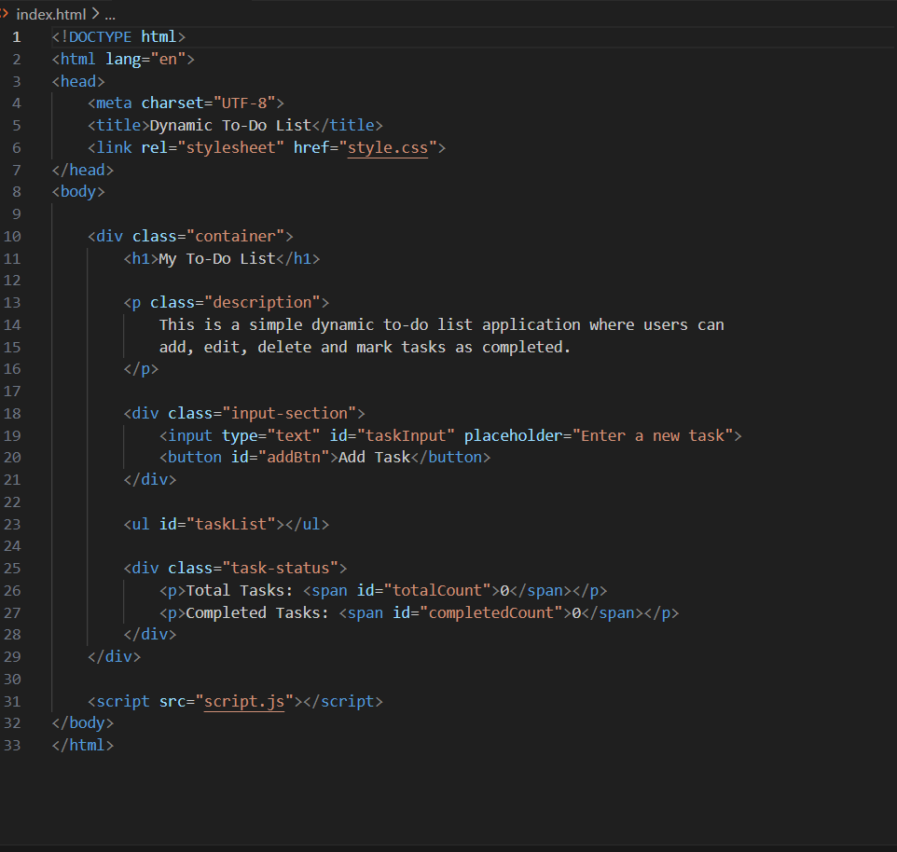

CSS-
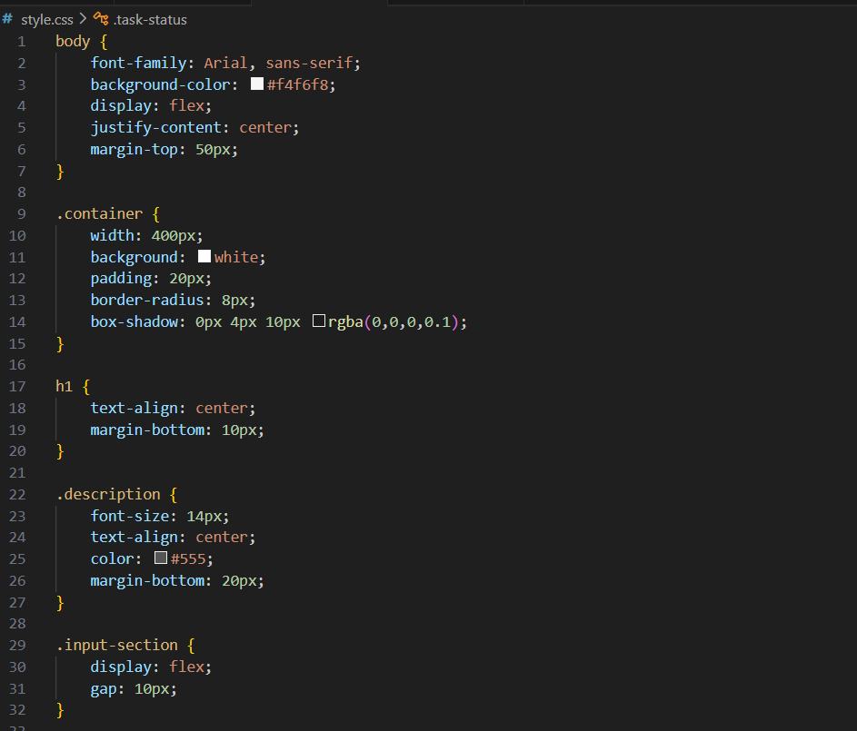
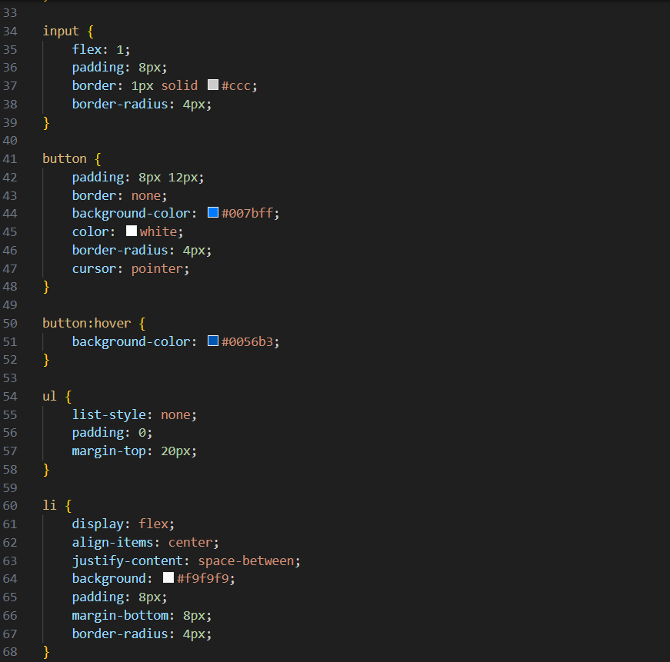
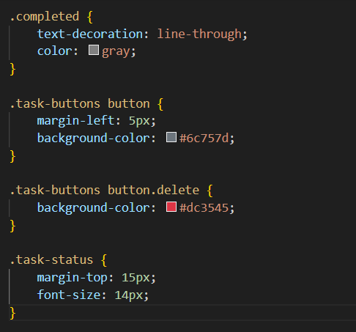

JAVASCRIPT-
